**Function Generator using Arduino and AD9833 IC**

**Abstract**

This project presents the design and implementation of a compact, low-cost function generator using the AD9833 Direct Digital Synthesis (DDS) module controlled by an Arduino microcontroller. The system can generate sine, square, and triangle waveforms with programmable frequency and phase, providing users with essential signal outputs for testing and experimentation.

A rotary encoder and pushbutton serve as the primary user input mechanism, allowing intuitive control over signal parameters, while a 16x2 I2C LCD displays real-time feedback, including waveform type, frequency, and phase. The AD9833 module communicates with the Arduino via the SPI interface, enabling precise waveform generation with minimal hardware overhead.

This function generator is ideal for use in educational laboratories, hobbyist projects, and basic circuit debugging, offering a reliable and user-friendly alternative to commercial signal generators at a fraction of the cost.

**Problem Statement**

Function generators are essential for testing and debugging electronic circuits, but commercial models are often expensive, bulky, and complex. Affordable alternatives typically lack precision, flexibility, and user-friendly interfaces. To address this, the project aims to develop a compact, low-cost, and easy-to-use function generator making it ideal for students, hobbyists, and basic lab use.

**Objectives**

* To design and implement a low-cost, Arduino-based function generator using the AD9833 DDS module.
* To generate three selectable waveform types: **sine, square, and triangle**.
* To provide an adjustable **frequency range from 1 Hz to 12.5 MHz**, with fine resolution.
* To implement **phase control**.
* To deliver a maximum output amplitude of up to **12V peak-to-peak** using an external amplification circuit.
* To enable real-time user interaction through a rotary encoder for parameter adjustment and a pushbutton for menu navigation.

**I. Introduction**

This project addresses these limitations by developing a compact, low-cost function generator based on the AD9833 Direct Digital Synthesis (DDS) module and an Arduino microcontroller, along with supporting components. The system can generate **sine**, **square**, and **triangular** waveforms with adjustable frequency ranging from **1 Hz to 12.5** MHz, phase control, and variable output amplitude.

Since the AD9833 provides a maximum output of approximately **0.6** **V** peak-to-peak, an external amplification stage is used to increase the signal amplitude, allowing it to be varied up to **12 V** **peak-to-peak**. This makes the function generator suitable for a wide range of general-purpose testing and signal simulation tasks.

The overall system is divided into three main sections:

1. **Power Supply Section** – Provides regulated **5V** and **±12V** as outputs from **220v** required by the digital circuitry and amplification stage, respectively.
2. **Digital Section –** Comprises the Arduino microcontroller, AD9833 module, rotary encoder, and 16x2 I2C LCD. This section handles waveform generation, waveform and frequency selection, user interface, and communication between modules.
3. **Analog Section** – In this section the waveform produced from the AD9833 is fed into the external amplifier which is used to the select the desired amplitude with the help of a potentiometer to a

maximum of **12V** peak-to-peak ensuring compatibility with a broader range of electronic circuits and test environments.

**II. Schematic Diagram**

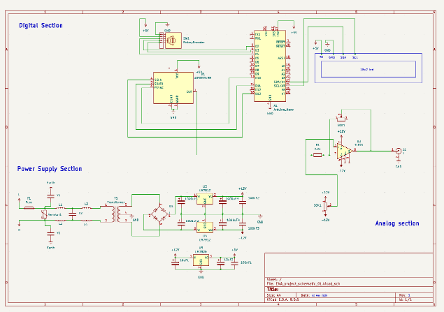

**Figure 1**

**III. Hardware**

**Figure 2**

**IV. Methodology**

The development of the function generator was carried out in a systematic manner, divided into distinct stages covering hardware design, software development, and system integration. The overall methodology ensures the successful generation of sine, square, and triangular waveforms with adjustable frequency, phase, and output amplitude. The system is designed around three major sections: the Power Supply, Digital, and Analog section.

**Hardware**

1. **Power Section**

The power supply unit is a fundamental part of the function generator system, designed to deliver clean and stable voltage levels to all components. The input stage begins with an **interference filter**, which plays a crucial role in eliminating high-frequency electromagnetic interference. This filter effectively suppresses both common-mode and differential-mode noise using class X and class Y capacitors, ensuring that the system remains protected from high frequency interferences.

Following the interference filter, a **12V centre-tapped** transformer is used to step down the AC mains voltage to a suitable level for rectification. The secondary output of the transformer is connected to a full-wave bridge rectifier, which converts the AC voltage into pulsating DC. This rectified voltage is then filtered using large electrolytic capacitors to reduce ripple and provide a smoother DC voltage for regulation.

To generate the required DC voltage levels, three linear **voltage regulators** are employed. The **LM7805** regulator provides a stable **+5V DC** supply, which powers the Arduino microcontroller, the AD9833 module, the I2C-based LCD display, and the rotary encoder. In addition, an **LM7812** is used to provide a **+12V** output, while an **LM7912** is used for generating a **-12V** output. These **±12V** supplies are necessary for the operational amplifier stage, which is used to boost the output waveform from the DDS module to the desired amplitude range.

Throughout the power distribution network, **decoupling capacitors** are strategically placed at the input and output of each voltage regulator and near all major integrated circuits. These capacitors serve to stabilize voltage levels, suppress noise, and enhance the overall reliability of the system by filtering out transient fluctuations and high frequency switching noise.

1. **Digital Section:**

The digital control section forms the central logic unit of the function generator system. It consists of an **Arduino** microcontroller, an **AD9833 Direct Digital Synthesis (DDS)** module, a **rotary encoder** with an integrated pushbutton, and a **16x2 LCD** display interfaced using the **I2C** (Inter-Integrated Circuit) communication protocol. The Arduino acts as the primary controller, managing communication with all components. It communicates with the AD9833 module via the Serial Peripheral Interface **(SPI)** to configure parameters such as output frequency, and waveform type.

User input is captured through the rotary encoder, which allows for both menu navigation and real time parameter adjustment. Rotational movements of the encoder are used to increment or decrement values of frequency, while pressing the encoder’s built-in pushbutton is used to switch waveform modes (sine, square, or triangle) and to toggle the output signal on or off.

The 16x2 I2C LCD serves as the primary output display, providing real-time feedback on the current system configuration. It displays information such as the selected waveform type, frequency, and on or off status.

To ensure responsive and accurate input processing, the rotary encoder’s movement and button presses are handled using interrupt-based event detection**.**

1. **Analog Section**

This section amplifies the waveform generated by the **AD9833 module** to achieve the desired output amplitude suitable for external applications. While the AD9833 can produce sine, square, and triangular waveforms with accurate, its native output amplitude is relatively low—approximately **0.6V peak-to-peak**. To increase this to a more usable level, a **TL071 low-noise operational amplifier** is employed in an **inverting amplifier configuration.**

A **50k potentiometer** is used in the feedback path of the op-amp circuit to allow for manual adjustment of the **amplification gain**, enabling fine-tuning of the output signal amplitude up to **12V peak-to-peak**.

In addition, a **10k potentiometer** is connected to provide an **offset control**, which allows for shifting of the output signal as needed, particularly useful in waveform alignment.

The operational amplifier is powered using a **dual supply of +12V and -12V**, which is derived from the regulated voltages generated in the power supply section. This dual-rail configuration enables the op-amp to handle both positive and negative signal swings, essential for accurately amplifying bipolar waveforms without distortion.

**Software Implementation**

The firmware is developed using the Arduino IDE in a modular structure enables efficient, responsive operation of the function generator and is structured around six key modules:

1. **Initialization:**  
   The system sets up the LCD, AD9833 via SPI, and configures the rotary encoder and pushbutton.
2. **Main Loop:**  
   Continuously checks for button presses and encoder rotation to handle user input. Depending on input, it updates frequency, phase, or waveform mode.
3. **Menu State Machine:**  
   A five-state menu system allows the user to view settings, select parameters, adjust frequency, and toggle waveform or power (On/off).
4. **Interrupt Handler:**  
   The encoder uses interrupts to detect direction and apply value changes with boundary checks. This ensures smooth and accurate adjustments.
5. **LCD Display:**  
   The display updates dynamically to reflect the current menu state, with highlighting to indicate active parameters.
6. **AD9833 Control:**  
   Final values are written to the AD9833 via SPI to update the output waveform in real time.

This modular structure enables efficient, responsive operation of the function generator.

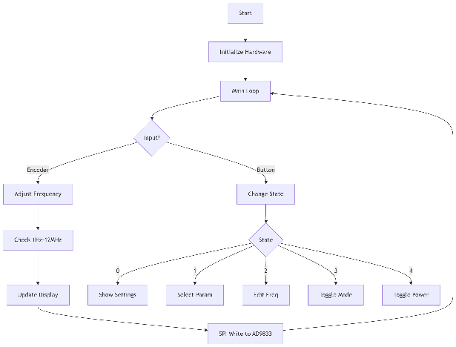

**V. Analysis**

The function generator was tested to evaluate waveform quality, frequency accuracy, output stability, and user interface responsiveness. Each waveform type—sine, square, and triangle—was examined using a digital oscilloscope to verify shape integrity and frequency precision.

For demonstration, a square waveform was selected and configured at a frequency of 1 kHz. The output was observed using an oscilloscope connected to the BNC output of the amplifier stage. The waveform exhibited a consistent rise and fall slope, confirming accurate square waveform synthesis from the AD9833 however **there was a problem** when measuring square wave particularly which we will discuss in the next section. Minimum distortion was observed, indicating that the amplification circuit preserved the waveform’s characteristics without significant signal degradation.

The frequency measured by the oscilloscope closely matched the value set via the rotary encoder and displayed on the LCD, with negligible deviation.

User interaction via the rotary encoder and pushbutton was found to be smooth and responsive. Menu transitions and parameter updates occurred in real-time without system delays or freezing.

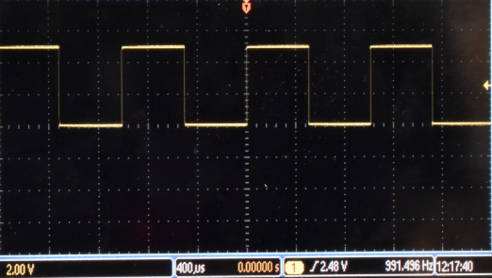Oscilloscope output screenshots (e.g., square waveform at 1 kHz) are included in the report to validate the results visually. **Figure 3**

**VI. Important Findings**

* The function generator successfully outputs clean and stable square, sine, and triangular waveforms with selectable frequency and waveform type.
* The square wave output, while visually sharp and consistent, revealed a unique issue during testing: the oscilloscope consistently displayed half the frequency compared to the set value. This anomaly was only observed in the square wave mode, while sine and triangular waves matched the expected frequencies accurately.
* The external amplifier circuit achieved a peak-to-peak output of up to 12V, making the signal suitable for different applications.
* However, the current design does not include amplitude monitoring functionality, meaning there is no way to confirm the actual output amplitude without using an external measuring instrument, such as an oscilloscope or multi meter.
* The user interface—consisting of a rotary encoder and pushbutton—proved to be effective and responsive.
* During testing, it was noted that the waveform output at frequencies above 2–3 MHz exhibited significant noise and distortion, making the signal unreliable at higher frequencies. This issue is primarily attributed to the breadboard-based prototype, which is inherently more susceptible to signal integrity problems and electromagnetic interference.
* It is expected that implementing the design on a proper PCB with appropriate grounding, trace routing, and decoupling will significantly reduce noise, especially at higher frequencies, thereby improving overall signal quality and usability in professional applications.
* The modular structure of both hardware and software allows for future upgrades.

**VII. Conclusion**

This project successfully demonstrates the design and implementation of a compact, low-cost function generator based on the AD 9833 (DDS) module, controlled via an Arduino microcontroller. The system generates sine, square, and triangular waveforms with selectable frequencies ranging from 1 Hz to 12.5 MHz and delivers up to 12V peak-to-peak output through external amplification.

The generator proved to be user-friendly, offering intuitive control through a rotary encoder and real-time feedback via an I2C LCD. Testing verified accurate frequency generation and clean waveform output at low to mid-range frequencies.

However, certain limitations were observed—most notably, the square wave frequency was displayed at half the expected value on the oscilloscope, and high-frequency signals above 2–3 MHz suffered from noise and distortion due to breadboard-related signal integrity issues.

Despite these challenges, the project met its core objectives and provides a strong foundation for future enhancements. Implementing the system on a properly designed PCB and integrating amplitude monitoring capabilities would significantly improve overall performance and reliability, making it suitable for more demanding applications.